Year 10 Biology Exam revision Q+A HIGHER
Cells Q1-5, Organisation Q6-10, Infection Q11-15, Yr 9 Ecology Q16-19
Q1.
The image below shows part of a root from a cress plant.
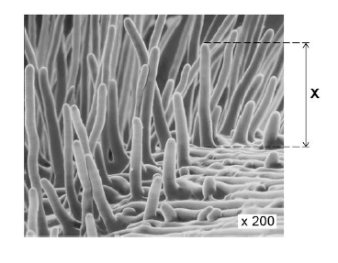
(a) What type of microscope was used to create the image above?
___________________________________________________________________
(1)
(b) The magnification of the cress root in the image above is × 200.
There are 1000 micrometres (μm) in a millimetre (mm).
Calculate the real length of the root hair, X.
Give your answer in micrometres (μm).
___________________________________________________________________
___________________________________________________________________
___________________________________________________________________
___________________________________________________________________
Real length X = ____________________ μm
(2)
(c) Root hair cells take up water from the soil.
Explain one way in which the root hair cell is adapted to this function.
___________________________________________________________________
___________________________________________________________________
___________________________________________________________________
___________________________________________________________________
(2)
The table shows the water uptake by a plant’s roots on two different days.

 | Mean water uptake in cm³ per hour
Cold day | 1.8
Hot day | 3.4
(d) Explain why the mean rate of water uptake is higher on a hot day than on a cold day.
___________________________________________________________________
___________________________________________________________________
___________________________________________________________________
___________________________________________________________________
___________________________________________________________________
___________________________________________________________________
(3)
(e) The concentration of mineral ions in the soil is lower than in root hair cells.
Root hair cells take up mineral ions from the soil.
Root hair cells contain mitochondria.
Explain why root hair cells contain mitochondria.
___________________________________________________________________
___________________________________________________________________
___________________________________________________________________
___________________________________________________________________
___________________________________________________________________
___________________________________________________________________
___________________________________________________________________
___________________________________________________________________
(4)
(Total 12 marks)
Q2.
Cells, tissues and organs are adapted to take in different substances and get rid of different substances.
The table shows the concentration of four ions outside cells and inside cells.

Ion | Concentration outside cells in mmol per dm³ | Concentration inside cells in mmol per dm³
Sodium | 140 | 9
Potassium | 7 | 138
Calcium | 2 | 27
Chloride | 118 | 3
(a) Use information from the table above to complete the following sentences.
Sodium ions will move into cells by the process
of __________________________________ .
Potassium ions will move into cells by the process
of __________________________________ .
(2)
(b) Some students investigated the effect of the different concentrations of sugar in four drinks, A, B, C and D, on the movement of water across a partially permeable membrane.
The students:
• made four bags from artificial partially permeable membrane
• put equal volumes of 5% sugar solution in each bag
• weighed each bag containing the sugar solution
• placed one bag in each of the drinks, A, B, C and D
• after 20 minutes removed the bags containing the sugar solution and weighed them again.
The diagram below shows how they set up the investigation.
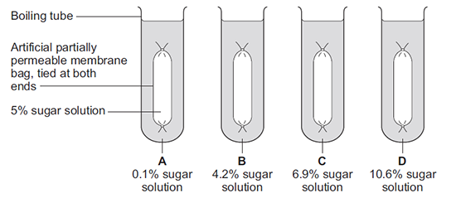
(i) The bag in drink A got heavier after 20 minutes.
Explain why.
______________________________________________________________
______________________________________________________________
______________________________________________________________
______________________________________________________________
(3)
(ii) In which drink, A, B, C or D, would you expect the bag to show the smallest change in mass?

Tick (✔) one box.

A |  |  | B |  |  | C |  |  | D
(1)
(iii) Explain why you think the bag you chose in part (b)(ii) would show the smallest change.
______________________________________________________________
______________________________________________________________
______________________________________________________________
______________________________________________________________
(2)
(Total 8 marks)
Q3.
The photograph shows a red blood cell in part of a blood clot. The fibres labelled X are produced in the early stages of the clotting process.
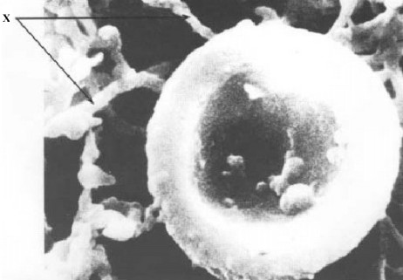
(a) Suggest how the fibres labelled X help in blood clot formation.
___________________________________________________________________
(1)
(b) The average diameter of a real red blood cell is 0.008 millimetres.
On the photograph, the diameter of the red blood cell is 100 millimetres.
Use the formula to calculate the magnification of the photograph.
Diameter on photograph = Real diameter × Magnification
___________________________________________________________________
___________________________________________________________________
___________________________________________________________________
Magnification = _______________________________
(2)
(c) Some blood capillaries have an internal diameter of approximately 0.01 millimetres.
(i) Use information given in part (b) to explain why only one red blood cell at a time can pass through a capillary.
______________________________________________________________
(1)
(ii) Explain the advantages of red blood cells passing through a capillary one at a time.
______________________________________________________________
______________________________________________________________
______________________________________________________________
______________________________________________________________
______________________________________________________________
______________________________________________________________
(3)
(Total 7 marks)
Q4.
Plant roots obtain some of their mineral salts from the soil by active transport.
What is involved in active transport?
_______________________________________________________________________
_______________________________________________________________________
_______________________________________________________________________
_______________________________________________________________________
_______________________________________________________________________
_______________________________________________________________________
_______________________________________________________________________
_______________________________________________________________________
(Total 4 marks)
Q5.
Some students set up an experiment using osmosis to find the concentration of sucrose solution in potato cell sap. They used discs of potato cut to the same size and weighing approximately 10 gms. The discs were put into each of five beakers.
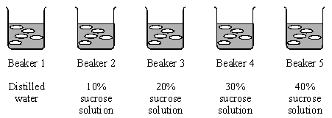
(a) (i) After two hours they reweighed the discs after carefully blotting them first. Why did the students blot the potato before weighing it?
______________________________________________________________
______________________________________________________________
(1)
(ii) Their results are shown in the table below.

 | Beaker 1 | Beaker 2 | Beaker 3 | Beaker 4 | Beaker 5
Final mass in g | 13.0 | 12.2 | 9.0 | 7.9 | 7.3
Initial mass in g | 10.0 | 10.6 | 10.0 | 10.1 | 10.4
The students calculated the % gain or loss in mass of potato. Complete this table of results for Beakers 2, 4 and 5.

Beaker 1 | Beaker 2 | Beaker 3 | Beaker 4 | Beaker 5
13 – 10.0 = 3.0  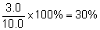 |  | 9.0 – 10.0 =  –1.0  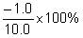  = –10%
Gain in mass = 30% |  | Loss in mass = 10%
(3)
(b) (i) Draw a graph of % Gain or Loss in mass against sucrose concentration.
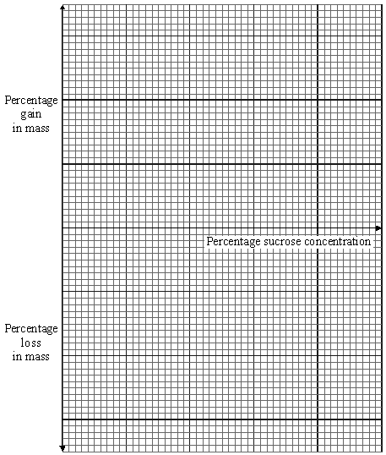
(3)
(ii) Use the graph to find the concentration of potato cell sap.
Concentration of cell sap = _____________________ % sucrose solution
(1)
(iii) Explain in terms of osmosis how you chose this value.
______________________________________________________________
______________________________________________________________
______________________________________________________________
(2)
(Total 10 marks)
Q6.
Enzymes are made and used in all living organisms.
(a) What is an enzyme?
___________________________________________________________________
___________________________________________________________________
___________________________________________________________________
___________________________________________________________________
(2)
(b) Many enzymes work inside cells.
In which part of a cell will most enzymes work?
Draw a ring around the correct answer.
cell membrane cytoplasm nucleus
(1)
(c) We can also use enzymes in industry.
Hydrogen peroxide is a chemical that can be used to preserve milk.
Adding a small amount of hydrogen peroxide to the milk kills the bacteria that cause decay. Hydrogen peroxide does not kill all disease-causing bacteria.
The enzyme catalase can be added later to break down the hydrogen peroxide to oxygen and water.
A different way of preserving the milk is by heating it in large machines to 138 °C for a few seconds.
Suggest one advantage and one disadvantage of using hydrogen peroxide and catalase to preserve milk instead of using heat treatment.
Advantage of hydrogen peroxide and catalase ______________________________
___________________________________________________________________
___________________________________________________________________
Disadvantage of hydrogen peroxide and catalase ___________________________
___________________________________________________________________
___________________________________________________________________
(2)
(Total 5 marks)
Q7.
Lipase is an enzyme that digests fat.
(a) (i) Complete the equation to show the digestion of fat.
Use the correct answer from the box.

glucose | glycerol | glycogen
fat fatty acids + ___________________
(1)
(ii) Name one organ that makes lipase.
______________________________________________________________
(1)
(b) Some students investigated the effect of bile on the digestion of fat by lipase.
The students:
1 mixed milk and bile in a beaker
2 put the pH sensor of a pH meter into the beaker
3 added lipase solution
4 recorded the pH at 2-minute intervals
5 repeated steps 1 to 4, but used water instead of bile.
Suggest two variables that the students should have controlled in this investigation.
1. _________________________________________________________________
___________________________________________________________________
2. _________________________________________________________________
___________________________________________________________________
(2)
(c) The graph shows the students’ results.
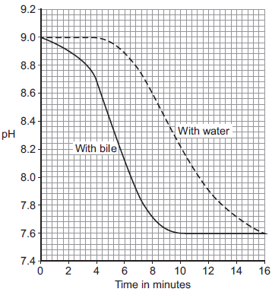
(i) Why did the pH decrease in both investigations?
______________________________________________________________
______________________________________________________________
(1)
(ii) Bile helps lipase to digest fat.
What evidence is there in the graph to support this conclusion?
______________________________________________________________
______________________________________________________________
(1)
(iii) Suggest one reason why the contents of both beakers had the same pH at the end of the investigations.
______________________________________________________________
______________________________________________________________
(1)
(Total 7 marks)
Q8.
Diagram 1 shows a section through the heart.
Diagram 1
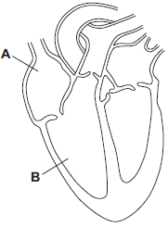
(a) Use words from the box to name the structures labelled A and B on Diagram 1.

aorta | atrium | pulmonary artery | ventricle
A ___________________________________________________________
B ___________________________________________________________
(2)
(b) The tissue in the wall of the heart contracts.
(i) What type of tissue is this?
Tick () one box.
muscular
glandular
epithelial
(1)
(ii) What does the heart do when this tissue contracts?
______________________________________________________________
______________________________________________________________
(1)
(c) Draw arrows on Diagram 2 to complete the route taken by deoxygenated blood through the heart.
Diagram 2
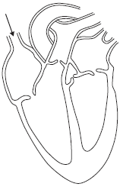
(2)
(d) The graph shows the percentage (%) of adults in the UK who have coronary heart disease.
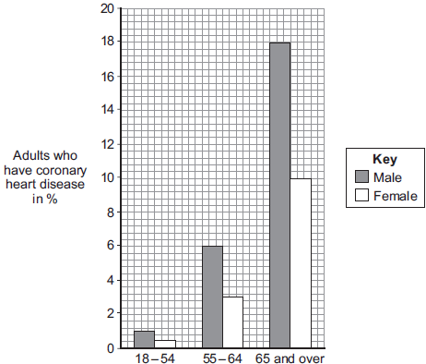
Age group
(i) Look at the graph.
Which group of people is most at risk of having coronary heart disease in the UK?
______________________________________________________________
(2)
(ii) Explain what happens to the heart in coronary heart disease.
______________________________________________________________
______________________________________________________________
______________________________________________________________
______________________________________________________________
______________________________________________________________
______________________________________________________________
(3)
(Total 11 marks)
Q9.
Diagrams A, B and C show cells from different parts of the human body, all drawn to the same scale.
A B C
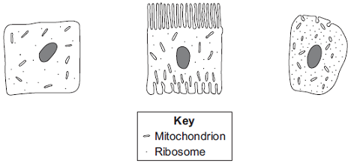
(a) Which cell, A, B or C, appears to be best adapted to increase diffusion into or
out of the cell?
Give one reason for your choice.
___________________________________________________________________
___________________________________________________________________
(1)
(b) (i) Cell C is found in the salivary glands.
Name the enzyme produced by the salivary glands.
______________________________________________________________
(1)
(ii) Use information from the diagram to explain how cell C is adapted for producing this enzyme.
______________________________________________________________
______________________________________________________________
______________________________________________________________
______________________________________________________________
(2)
(Total 4 marks)
Q10.
The heart pumps blood to the lungs and to the cells of the body.
(a) Name the blood vessel that transports blood from the body to the right atrium.
___________________________________________________________________
(1)
(b) The aorta transports blood from the heart to the body.
In a person at rest:
• blood travels at a mean speed of 10 cm/s in the aorta
• blood travels at a mean speed of 0.5 mm/s in the capillaries
• the speed of blood decreases at a rate of 0.4 cm/s² as blood travels from the aorta to the capillaries.
Calculate the time it takes for blood to travel from the aorta to the capillaries.
Assume that the speed of blood decreases at a constant rate.
Use the equation:
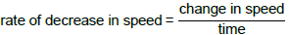
Give your answer to 2 significant figures.
___________________________________________________________________
___________________________________________________________________
___________________________________________________________________
___________________________________________________________________
___________________________________________________________________
___________________________________________________________________
___________________________________________________________________
Time = ____________________ s
(4)
(c) Describe the route taken by oxygenated blood from the lungs to the body cells.
___________________________________________________________________
___________________________________________________________________
___________________________________________________________________
___________________________________________________________________
___________________________________________________________________
___________________________________________________________________
___________________________________________________________________
___________________________________________________________________
(4)
(d) The digestive system and the breathing system both contain specialised exchange surfaces.
• In the digestive system, digested food is absorbed into the blood stream in structures called villi.
• In the breathing system, gases are absorbed into the blood stream in the alveoli.
The diagram below shows the structure of villi and alveoli.
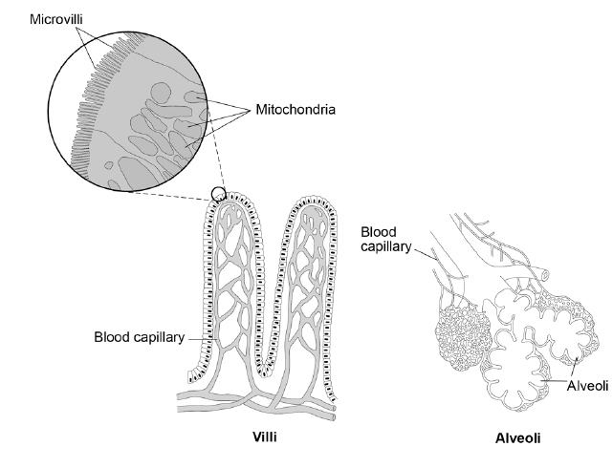
Explain how the villi and the alveoli are adapted to absorb molecules into the bloodstream.
(6)
(Total 15 marks)
Q11.
Eating food containing Salmonella bacteria can cause illness.
(a) Two symptoms of infection by Salmonella are vomiting and diarrhoea.
What causes these symptoms?
___________________________________________________________________
___________________________________________________________________
(1)
(b) Give two ways a person with a mild infection of Salmonella can help prevent the spread of the bacteria to other people.
1. _________________________________________________________________
___________________________________________________________________
2. _________________________________________________________________
___________________________________________________________________
(2)
(c) In very serious infections of Salmonella, a doctor can prescribe drugs to kill the bacteria.
What type of drug can the doctor prescribe to kill the bacteria?
___________________________________________________________________
___________________________________________________________________
(1)
(d) A person with AIDS may take longer than a healthy person to recover from a Salmonella infection.
Explain why.
___________________________________________________________________
___________________________________________________________________
___________________________________________________________________
___________________________________________________________________
(2)
(e) Salmonella bacteria can be transmitted from chickens to humans. Chickens can be vaccinated to prevent the transmission of Salmonella bacteria to humans.
Suggest one other way farmers could prevent the transmission of Salmonella from chickens to humans.
___________________________________________________________________
___________________________________________________________________
(1)
A restaurant owner employed a scientist to test the effectiveness of two kitchen cleaning liquids.
The scientist took samples from two work surfaces:
• before the surfaces had been cleaned with the cleaning liquids
• after the surfaces had been cleaned with the cleaning liquids.
The samples were then analysed for the number of bacteria they contained.
The results are shown in Figure 1.
Figure 1
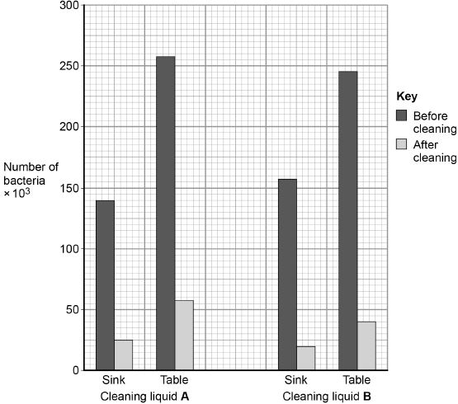
(f) Which cleaning liquid is the more effective?
Give a reason for your answer.
Cleaning liquid ______________
Reason ____________________________________________________________
___________________________________________________________________
___________________________________________________________________
(1)
The scientist investigated the effect of cleaning liquid A and cleaning liquid B on Salmonella bacteria grown in a laboratory.
Figure 2 shows the way the investigation was set up.
Figure 2
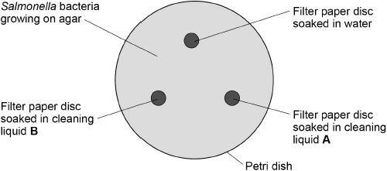
The Petri dish was placed in an incubator at 25 °C for 48 hours.
After 48 hours, the scientist calculated the area around each paper disc where no bacteria were growing.
The results are shown in the table below.

Filter paper disc | Area around disc with no bacteria growing in cm²
Water | 0
Cleaning liquid A | 11
Cleaning liquid B | 13
(g) What measurement would the scientist need to take to calculate the area where no bacteria were growing?
___________________________________________________________________
___________________________________________________________________
(1)
(h) Give one change to the investigation that would allow the scientist to check if the results are repeatable.
___________________________________________________________________
___________________________________________________________________
(1)
(i) The scientist showed the results to the restaurant owner.
Both cleaning liquids cost the same per dm³.
Suggest one other factor the restaurant owner should consider when choosing which cleaning liquid to use.
___________________________________________________________________
___________________________________________________________________
(1)
(Total 11 marks)
Q12.
New drugs have to be thoroughly tested before they are sold.
The diagram shows a time line for the testing of a new drug.
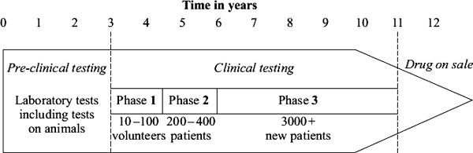
(a) What is the main purpose of pre-clinical testing?
___________________________________________________________________
___________________________________________________________________
(1)
(b) In Phase 1 of the clinical testing, very low doses of the new drug are used on a small number of volunteers.
(i) What is the main purpose of Phase 1 testing?
______________________________________________________________
______________________________________________________________
(1)
(ii) In Phase 1 testing, healthy volunteers are used rather than patients.
Suggest one reason for this.
______________________________________________________________
______________________________________________________________
(1)
(c) What is the main purpose of the Phase 2 and Phase 3 testing?
___________________________________________________________________
___________________________________________________________________
(1)
(d) During Phase 3 testing, many of the patients are given a placebo.
(i) What is meant by a placebo?
______________________________________________________________
______________________________________________________________
(1)
(ii) During the testing, who knows which patients are receiving the placebo?
Tick () one box.

Only the patients
Only the doctors
Both patients and doctors
Neither patients nor doctors
(1)
(Total 6 marks)
Q13.
Influenza is a disease caused by a virus.
(a) Explain why it is difficult to treat diseases caused by viruses.
___________________________________________________________________
___________________________________________________________________
___________________________________________________________________
___________________________________________________________________
(2)
(b) In some years there are influenza epidemics.
The graph shows the death rate in Liverpool during three influenza epidemics.
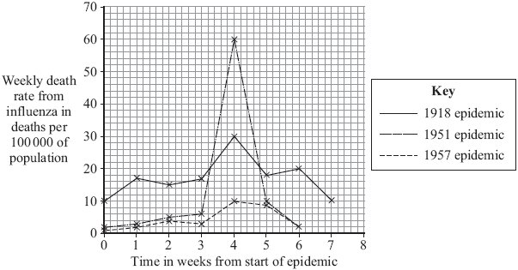
(i) The population of Liverpool in 1951 was approximately 700 000.
Calculate the approximate number of deaths from influenza in week 4 of the 1951 epidemic.
Show clearly how you work out your answer.
______________________________________________________________
______________________________________________________________
Number of deaths _______________
(2)
(ii) In most years, the number of deaths from influenza in Liverpool is very low.
Explain, in terms of the influenza virus and the body’s immune system, why there were large numbers of deaths in years such as 1918 and 1951.
______________________________________________________________
______________________________________________________________
______________________________________________________________
______________________________________________________________
______________________________________________________________
______________________________________________________________
(3)
(Total 7 marks)
Q14.
The diagram shows two methods which are used to give humans protection against disease. Method A shows active immunity and Method B shows passive immunity. Method A can be used against polio. Method B is often used against tetanus.
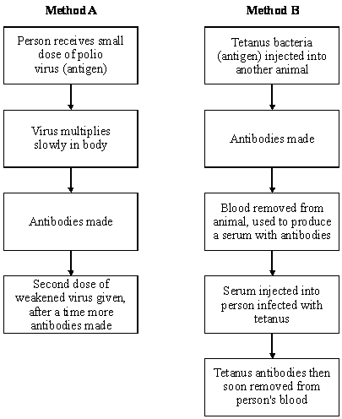
(a) What is the name of the substances produced by the body which destroy harmful viruses and bacteria?
___________________________________________________________________
(1)
(b) Why does Method A give long lasting protection against polio?
___________________________________________________________________
(1)
(c) Why does Method B not give long lasting protection against tetanus?
___________________________________________________________________
(1)
(d) In immunisation against polio a second dose of the weakened virus is given (this is known as a booster). Suggest why this booster is necessary.
___________________________________________________________________
(1)
(e) Method A would not be helpful for a person who had just been infected with tetanus bacteria. Explain the reason for this.
___________________________________________________________________
___________________________________________________________________
(2)
(f) Why is Method B very good for dealing quickly with an infection of tetanus?
___________________________________________________________________
(1)
(Total 7 marks)
Q15.
The MMR vaccine is used to protect children against measles, mumps and rubella.
(a) Explain, as fully as you can, how the MMR vaccine protects children from these diseases.
___________________________________________________________________
___________________________________________________________________
___________________________________________________________________
___________________________________________________________________
___________________________________________________________________
___________________________________________________________________
___________________________________________________________________
(3)
(b) Read the passage.

Autism is a brain disorder that can result in behavioural problems. In 1998,
Dr Andrew Wakefield published a report in a medical journal. Dr Wakefield and his colleagues had carried out tests on 12 autistic children.
Dr Wakefield and his colleagues claimed to have found a possible link between the MMR vaccine and autism.
Dr Wakefield wrote that the parents of eight of the twelve children blamed the MMR vaccine for autism. He said that symptoms of autism had started within days of vaccination.
Some newspapers used parts of the report in scare stories about the MMR vaccine. As a result, many parents refused to have their children vaccinated.
Dr Wakefield’s research was being funded through solicitors for the twelve children. The lawyers wanted evidence to use against vaccine manufacturers.
Use information from the passage above to answer these questions.
(i) Was Dr Wakefield’s report based on reliable scientific evidence?
Explain the reasons for your answer.
______________________________________________________________
______________________________________________________________
______________________________________________________________
______________________________________________________________
(2)
(ii) Might Dr Wakefield’s report have been biased?
Give the reason for your answer.
______________________________________________________________
______________________________________________________________
______________________________________________________________
(1)
(Total 6 marks)
Q16.
In this question you will be assessed on using good English, organising information clearly and using specialist terms where appropriate.
Ivy plants can grow up trees and walls.
Figure 1 shows two ivy leaves. One leaf is from an ivy plant growing up a tree in the centre of a shady woodland area. The other leaf is from an ivy plant growing up a tree in a sunny area at the edge of the woodland.
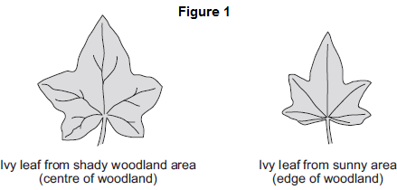
A student makes the following hypothesis.
“The size of ivy leaves decreases as light intensity increases.”
How would you use the apparatus shown in Figure 2 to test this hypothesis?
You should include details of how you would make sure the results are valid.
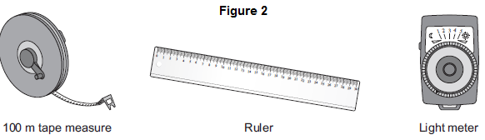
_______________________________________________________________________
_______________________________________________________________________
_______________________________________________________________________
_______________________________________________________________________
_______________________________________________________________________
_______________________________________________________________________
_______________________________________________________________________
_______________________________________________________________________
_______________________________________________________________________
_______________________________________________________________________
(Total 6 marks)
Q17.
Some students investigated the size of a population of dandelion plants in a field.
The diagram below shows the field.
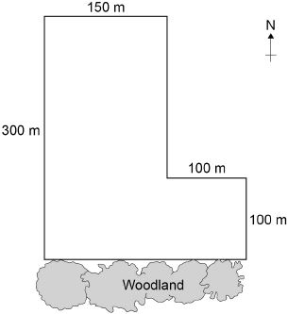
The students:
• placed a 1 m × 1 m square quadrat at 10 random positions in the field
• counted the number of dandelion plants in each quadrat.
The table below shows the students’ results.

Quadrat number | Number of dandelion plants
1 | 6
2 | 9
3 | 5
4 | 8
5 | 0
6 | 10
7 | 2
8 | 1
9 | 8
10 | 11
(a) Why did the students place the quadrats at random positions?
___________________________________________________________________
___________________________________________________________________
(1)
(b) Estimate the total number of dandelion plants in the field.
Calculate your answer using information from the diagram and the table above.
Give your answer in standard form.
___________________________________________________________________
___________________________________________________________________
___________________________________________________________________
___________________________________________________________________
___________________________________________________________________
___________________________________________________________________
___________________________________________________________________
___________________________________________________________________
___________________________________________________________________
___________________________________________________________________
Total number of dandelion plants = ____________________
(5)
Quadrats 5, 7 and 8 were each placed less than 10 metres from the woodland.
These quadrats contained low numbers of dandelion plants.
The students made the hypothesis:
‘Light intensity affects the number of dandelion plants that grow in an area.’
(c) Plan an investigation to test this hypothesis.
___________________________________________________________________
___________________________________________________________________
___________________________________________________________________
___________________________________________________________________
___________________________________________________________________
___________________________________________________________________
___________________________________________________________________
___________________________________________________________________
___________________________________________________________________
___________________________________________________________________
___________________________________________________________________
___________________________________________________________________
___________________________________________________________________
___________________________________________________________________
___________________________________________________________________
___________________________________________________________________
___________________________________________________________________
___________________________________________________________________
___________________________________________________________________
___________________________________________________________________
(6)
(d) Light is an environmental factor that affects the growth of dandelion plants.
Give two other environmental factors that affect the growth of dandelion plants.
1. _________________________________________________________________
2. _________________________________________________________________
(2)
(Total 14 marks)
Q18.
Students investigated a food chain in a garden.
lettuce → snail → thrush (bird)
The students:
• estimated the number of lettuce plants in the garden
• estimated the number of snails feeding on the lettuces
• counted two thrushes in the garden in 5 hours.
The table below shows the students’ results and calculations.

Organism | Population size | Mean mass of each organism  in g | Biomass of population  in g | Biomass from previous organism that is lost in g | Percentage of biomass lost
Lettuce | 50 | 120.0 | 6000
Snail | 200 | 2.5 | 500 | 5500 | 91
Thrush | 2 | 85.0 | 170 | 330 | 66
(a) (i) Give two ways that biomass is lost along a food chain.
______________________________________________________________
______________________________________________________________
______________________________________________________________
______________________________________________________________
(2)
(ii) Scientists estimate that about 90% of the biomass in food is lost at each step in a food chain.
Suggest one reason why the students’ value for the percentage of biomass lost between the snails and the thrushes is only 66%.
______________________________________________________________
______________________________________________________________
(1)
(b) European banded snails have shells with different colours (light or dark) and with stripes or with no stripes.
Figure 1 shows two examples of European banded snails.
Figure 1
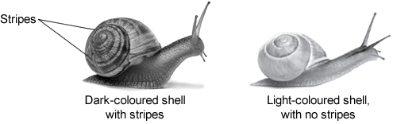
© Eric Lsselee/iStock © filipfoto/iStock
Figure 2 shows results from surveys in woodlands and in grasslands of the percentage of snails with light-coloured shells and the percentage of snails with no stripes.
Each point on the graph represents the results of one survey in one habitat.
Figure 2
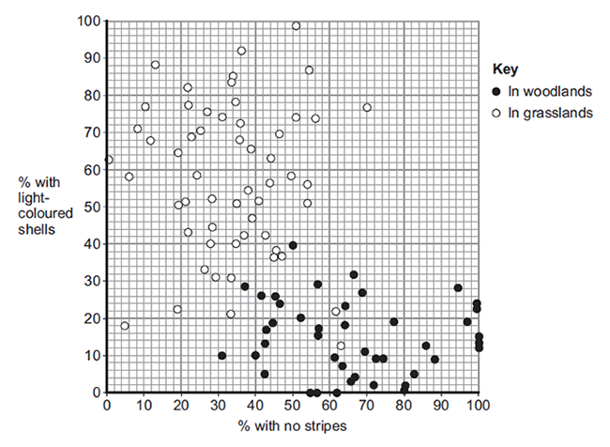
(i) Figure 2 is a scatter graph.
Why is a scatter graph used for this data?
______________________________________________________________
______________________________________________________________
(1)
(ii) Compare the general appearance of snails that live in woodlands with the general appearance of snails that live in grasslands.
______________________________________________________________
______________________________________________________________
______________________________________________________________
______________________________________________________________
(2)
(iii) Suggest a reason for the general appearance of snails that live in woodlands.
______________________________________________________________
______________________________________________________________
(1)
(Total 7 marks)
Q19.
In this question you will be assessed on using good English, organising information clearly and using specialist terms where appropriate.
Animals and plants have features (adaptations) that allow them to survive in the conditions in which they normally live.
Describe how animals and plants are adapted to survive in dry conditions such as deserts.
For each adaptation that you give, describe how the adaptation helps the animal or plant to survive in dry conditions.
To obtain full marks you should refer to both animals and plants.
_______________________________________________________________________
_______________________________________________________________________
_______________________________________________________________________
_______________________________________________________________________
_______________________________________________________________________
_______________________________________________________________________
_______________________________________________________________________
_______________________________________________________________________
_______________________________________________________________________
_______________________________________________________________________
_______________________________________________________________________
_______________________________________________________________________
Extra space _____________________________________________________________
_______________________________________________________________________
_______________________________________________________________________
_______________________________________________________________________
_______________________________________________________________________
_______________________________________________________________________
_______________________________________________________________________
(Total 6 marks)

